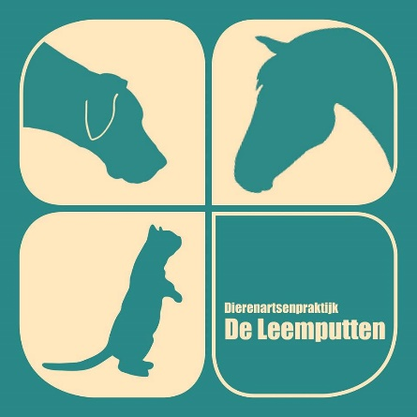

04/12/2024

**Declaration of pregnancy**

To whom it may concern,

Recipient mare name: M; UELN 528003201710562, chip number 528210004704853

Embryo: Cerly Van De Huffelen Z x Eldorado Van de Zeshoek

As an equine vet I hereby declare that I have performed the transfer of the above mentioned embryo into the above named recipient mare. I have examined the recipient mare by ultrasound today and found her to be pregnant with normal findings. There is a vital fetus present and placenta and fetal fluids have a normal appearance. The due date for foaling is 09/07/2025.

Kind regards,

Dierenarts Wim Jansens

DAP De Leemputten

Oudelijns 10

2381 Weelde

+32 492 585998

